BINARY CLOCK BUILD INSTRUCTIONS

This project/work consists of a electronic circuit, an associated circuit board design, microcontroller program (software) and supporting documents/information. Users are free to modify and/or utilize this project for any non-commercial use. THERE IS NO WARRANTY. ANY PART OF OR THE ENTIRE PROJECT/WORK, AS-IS OR AFTER MODIFICATION, MAY BE UNFIT FOR USE, UNSAFE OR DANGEROUS. USE AT YOUR OWN RISK! This project/work is licensed under the Creative Commons Attribution-NonCommercial-ShareAlike 4.0 International License. To view a copy of this license, visit http://creativecommons.org/licenses/by-sa/4.0/ or send a letter to Creative Commons, PO Box 1866, Mountain View, CA 94042, USA.

Note about POWER SUPPLY: The easiest way to power this circuit is with a "walwart" regulated power supply with an output of not more than 5VDC with at least 100 ma current capacity. If you don't fully understand this, please consult a knowledgable person before proceeding.

- Board Prep
  - Inspect the board. Look for bridges (maybe can be correcting by cutting) or gaps in traces (maybe bridge with solder or you’ll need to connect with jump wires on the bottom side) or missing pads or traces. Compare to a picture or another board for differences.
  - Cut to size if needed. Absolute max. size is 3.05 X 4.150” (to fit inside the plastic box). Measure with plastic calipers.
  - Remove any edge burr (sand or file).
- Drill Holes
  - The board needs 9 big holes: the 4 corners, 1 power supply wire and 4 PCB mounting holes. The four corners will be 5/16” to accept the legs in the clear plastic cover but for now we’re going to drill them out at 1/8”. The four mounting holes are for screws to hold the printed circuit board to the black plastic rear of the plastic case and only need to be 1/8". These holes are marked on the PCB pattern.
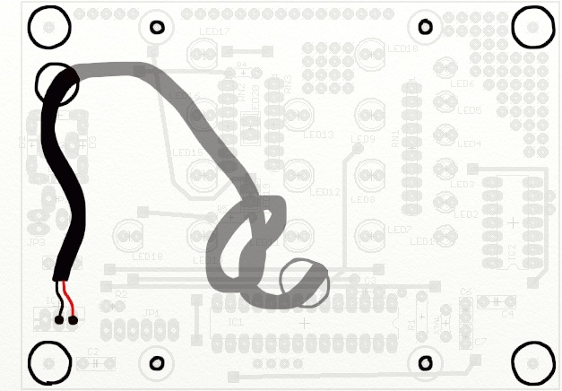

  - Using the Dremel drill press, drill the 9 holes with a 1/8" brad point drill bit.
SAFETY - Wear safety glasses. Use buddy system and buddy operates vacuum for dust control. Don’t breath the dust!
Position the holes exactly! Note: the collar that holds the 1/8” bit in the Dremel tool is a different size than what holds the 0.035/0.040” bits in the Dremel tool.
  - Drill one hole in the black plastic rear of the plastic case. Drill it in the bottom middle. Do not put it in line with the hole in the PCB. Drill this hole 1/8”.
  - Using the power hand drill, drill out 5 holes to 5/16” with the brad point drill bit (holes for the 4 corners and the power cord).
SAFETY – 14+ years old to drill these holes! Wear safety glasses. Wear a Kevlar glove on the PCB holding hand. Use buddy system to operate vacuum for dust control. Don’t breath this dust!
Work on a piece of wood so you don’t damage the table. Position holes exactly! Go gentle and slow! Let the bit start to turn before it starts to bite into the PCB. Do not run the drill at maximum speed!
  - Check whether the PCB will fit into the enclosure. Enlarge the corner holes with a round file if necessary.
- Remove Etch-Resist
  - Use acetone and paper towels to remove the red ink.
Safety - Wear rubber gloves. Avoid breathing the fumes.
  - Put a piece of blue tape on both halves of your plastic box. Use a sharpie to write your name or initials on the tape. Leave this label on the back until you get home.
  - Write you initials on the blank spot on the bottom of the PCB board using a paint pen.
- Drill Component Lead Holes
  - Using the Dremel drill press, drill the component lead holes.
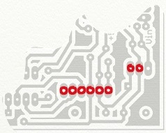
SAFETY - Wear safety glasses. Use buddy system and buddy operates vacuum for dust control. Don’t breath the dust! Do not drill into fingers! Wash hands when complete.
  - Practice on extra holes on board (square pads).
  - Drill eight (8) 0.040" (size #60) for the components that need larger holes (JP1 and the power supply wires).
  - Drill all other component holes 0.035" (size #65). Note: the square pads do not need to be drilled out. They are extra either for practice or for expansion/project modifications.
  - Drill two 0.035" holes extra (unmarked) in the copper fill next to JP1 as shown below. These are for resistor #3 (R3) in step 9.3.
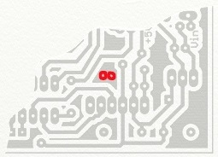
- Cut Wires
  - Note - It's easier to remove insulation from the loose end before cutting from the roll of wire. Remove the ¼” of insulation from the loose end. Measure and cut the piece you need. Then remove the insulation from the other end. These lengths include room for a 1/4" of bare wire at each end. When using the wire strippers, use the correct size to cut the insulation, then pull the insulation off the wire with your fingernail. Use the size hole just big enough to cut the insulation. If you use a size too small, the wire inside will get partially cut and will easily break off.
  - Cut these wires: red: 2.5 inches, black 2.25” (two of them), blue 1.5”, orange 2” (two of them), yellow 2 5/8”.
- Collect your parts per the parts list.
  - Pick out the color of LEDs you would like to use for your clock. The standard LEDs are:
Hours & Minutes - 5mm round red – quantity 12 (754-1264).
Separator (colon) - 2x5 mm rectangular red – quantity 2 (754-1201).
Seconds - 3mm round green – quantity 6 (754-1603).
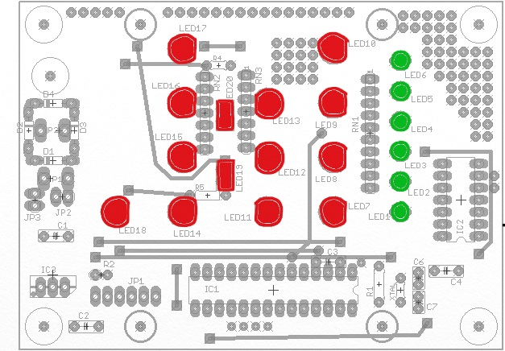
Alternative LEDs that may be available
Hrs & Minutes | 5mm Green | 859-LTL-4233
 | 5mm Amber | 859-LTL-307A
Separator | 5mm Amber | 160-1966 | Use R4 &R5 1K ohms
 | 5mm Yellow | 754-1284 | Use R4 &R5 1K ohms
 |  | 754-1740 | Use R4 &R5 1K ohms
 | 3mm Red | 160-1708 | Use R4 &R5 750 ohms
 | 3mm Yellow | 604-WP132XYD | Use R4 &R5 1K ohms
 | 3mm Amber | 160-1940 | Use R4 &R5 750 ohms
 | 3mm Green | 754-1603 | Use R4 &R5 1K ohms
Seconds | 3mm Yellow | 604-WP132XYD
 | 3mm Red | 604-WP132XID
 | 3mm Amber | 160-1940

  - Collect other parts from the parts box. The inside of the lid indicates the parts & quantity needed.

- Solder R1 (Resistor #1)
SAFETY – Wear safety glasses! Solder contains lead (toxic). Don’t eat while handling solder. Wash hands when complete.
  - First practice by soldering 2 salvaged parts to a small piece of perf-board. Show your work before continuing.
  - Solder R1 in place. It is a 100 ohm resistor with colors brown-black-brown.

NOTE: To hold the part in place for soldering, either bend the leads outward a little bit or use a piece of blue painter’s tape. (The part should be on the bare side of the board. The metal leads [“legs”] go through and the soldering is done on the side with the copper traces.)
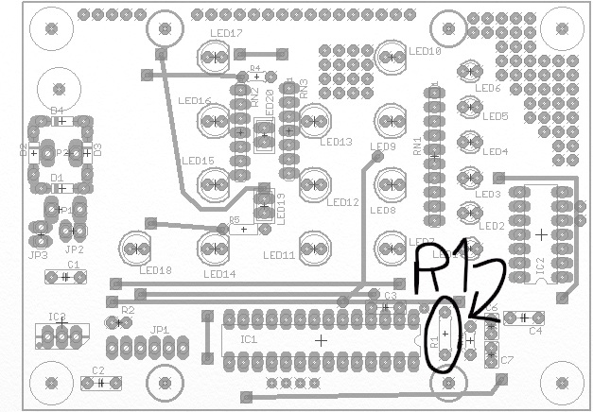

- Build & test power supply circuit
  - Add JP1. The short length of the pins should go through the board and get soldered. The plastic part and the long length of the pins should stick up on the component side of the board.
  - Add C2.
  - Add R2 (green-brown-red). This resistor stands up. Only bend one lead, 180 degrees so the lead is parallel to the resistor body. It goes next to JP1.
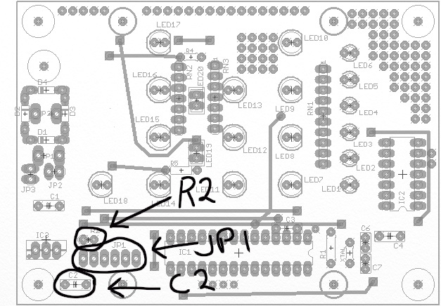
  - R4 & R5 (430ohm, Yellow-Orange-Brown). Abnormal mounting! It is a common error to put these in the wrong holes. Check against a completed board that works before placing these resistors! (The value of these resistors may need to be different if you’re using different LEDs for LED18 & LED19.). The resistor leads should skip over the holes labeled "SKIP".
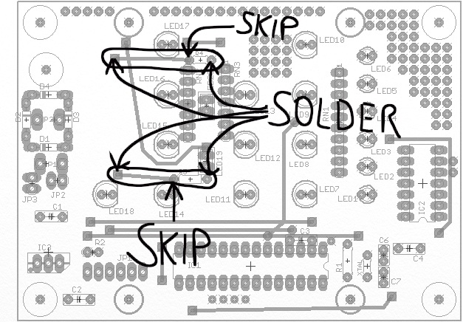
“SKIP” in this drawing means skip over the hole under the part at the arrow.

  - Add one black wire. This wire should be bent as shown to avoid other components. Adjust the length of wires as needed to get them to lay neatly against the PCB.
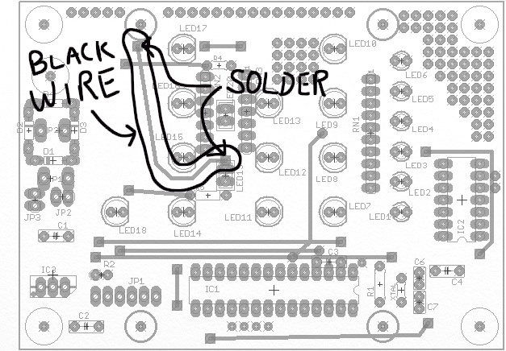

  - Add LED19 & LED20. Orientation of LEDs must be correct! The LEDs have a short lead and a long lead. The short lead is the cathode and goes to ground which is the black wire you just installed in between these two LEDs.
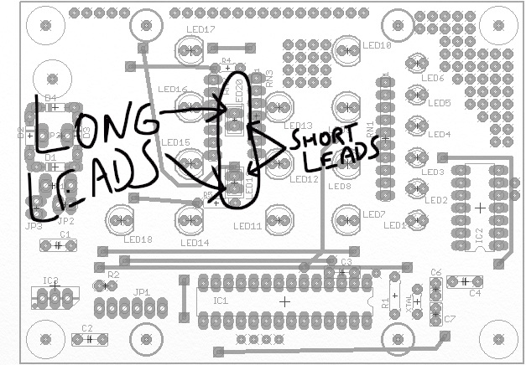
Note: Save 2 pieces of leads for use in step 9.5.
  - Test your circuit with the power supply labeled TEST (5V). Push the black wire onto the 3rd pin from the left of JP2 (ground). Touch the red wire to the 2nd pin of JP2. LED19 & LED20 should come on.
- Add More Parts
  - Add these three wires: black, blue and orange.
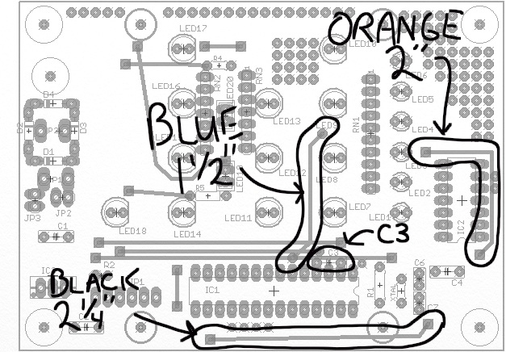
Leave just a bit of slack in the black wire so it can go around the mounting screw to be added later.
The orange wire must go around IC2.

  - Add C3.
  - Add the yellow wire (see below). It should go to one of the two extra holes drilled in step 4.5. Also add R3 (brown-black-brown) to complete the circuit for the yellow wire.
  - Add these two wires: red and orange wires. Watch where these go on the board - builders sometimes make an error with these and place them in the wrong place!

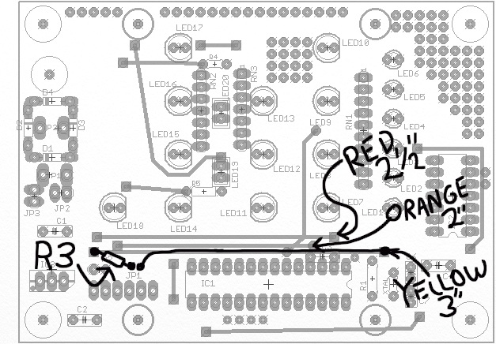

  - Use two cut off component leads to make wire jumpers. Bend them at 0.3”. Add where shown in picture below.
  - Add RN1, RN2 and RN3. Orientation must be correct! Pin #1 of the RN should be toward the top of the board. Pin #1 on the part has a dot on it. For each part, solder a pin at one end first. Check and make sure the part is in all the way and straight. If not, hold the part with a finger, reheat the joint and while the solder is molten, push it in correctly with your finger. Then solder the other pins.
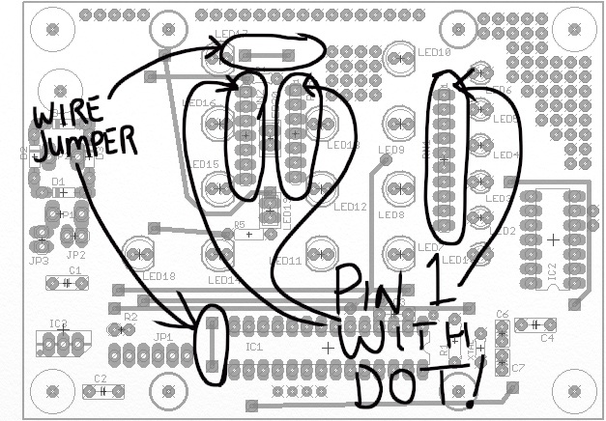
  - Install a 3mm seconds LED (LED1) and four other 5mm LEDs (LEDs 7, 11, 14 & 18). Orientation must be correct! The short lead of the LED is the cathode and goes to ground – ground in this circuit is the resistor networks. The cathode is also marked with a flat spot on the LED. This is also shown in the PCB picture below.
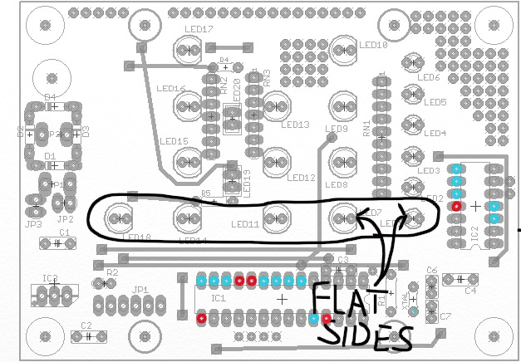
Note: The green LEDs don’t seem to have the flat spot. Look for the short lead.

  - Install sockets for IC1 and IC2. Orientation must be correct! Note that one end has a notch and should match the notch on the diagram. Both notches point to the same corner (bottom right). Solder all the pins but only do every other pin. Then go back and solder the remaining pins.
  - Test your circuit with the power supply labeled TEST (5V). Push the black wire onto the 3rd pin from the left of JP2 (ground). Touch the red wire to the test pins shown above in red. Each pin should turn on one LED.
  - Install the remaining LEDs. Orientation must be correct!
  - Test all of the remaining LEDs. Touch the red power supply wire to the test pins shown above in blue. Each pin should turn on one LED.
- Add remaining components.
  - Add all remaining components (C4, C6, C7, XTAL).
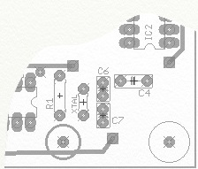
  - The holes for C6 & C7 may be closer spaced than those on the parts (it depends on which exact part was ordered). If needed, straighten the leads with needlenose pliers before placing on PCB to line up the capacitor leads with the holes on the PCB board.
  - Insert PIC and IC2 in the sockets. Use a credit card or something similar to straighten the legs against the tabletop if they’re splayed-out. Make sure pins are lined up before pressing the IC into the socket.
  - Thread power supply wire thru the plastic enclosure. Tie a knot for a strain relief. Thread it through the PCB. Solder it to the PCB to the outer pins of IC3. This must be oriented correctly! The (+) wire goes to V+.
  - Program PIC with Binclk.asm. (What time is it when you plug it in?)
  - Test it. Does it work? If not, disconnect power quickly.
  - Troubleshooting. (He who makes the most mistakes, learns the most.)
- Final Assembly
  - Cut 3 spacers from tubing 0.3” each (5/16”).
  - Using spacers and the #4 screws, mount the PCB to the black back of the plastic enclosure. Be gentle with the screws into plastic or you’ll strip them out. Don’t screw them in too deep because they’ll come out the back! (Feel for bumps as they start to come thru.)
  - Use the screws that came with the plastic case to hold the case together.
  - Plug in for operation.
  - Un-plug/re-plug at 5:42 (AM or PM ) to set the proper time.

